MSCF Financial Computing I

Mini 1, 2021
Homework 1

Due At 11:59 pm Saturday, Sept. 4, 2021

You will lose 10 points per hour after that time

- (20 points) Wes McKinney, Pandas BDFL (Benevolent Dictator For Life)

Wes McKinney is the originator of the Pandas module for Python, and is officially the
Pandas BDFL. His book, Python for Data Analysis: Data Wrangling with Pandas,
NumPy, and IPython, 2nd Edition is an outstanding reference for Pandas, NumPy, and
several other data analysis modules in the Python “ecosystem.” It is available for free
online through the Carnegie Mellon University Library.

We will use NumPy and Pandas (and other) facilities in homework assignments for the
rest of this course, and you will use them in future MSCF courses, as well. But we won’t
spend more lecture time on them, for the most part.

For the first part of Homework 1, you should read Chapter 2 of McKinney’s book and
become familiar with Jupyter notebooks, if you are not too familiar with Jupyter already.
(It will not harm you to read Chapter 1 and Chapter 3, but it’s not required.)

- Using a Jupyter notebook named HW1_part_1a, read Chapter 4, NumPy Basics: Arrays and Vectorized Computation and try all of the examples. About 70% of this material will be review, but McKinney goes into more depth on several topics. Save your Jupyter notebook for submission as part of Homework 1.

- Using another Jupyter notebook named HW1_part_1b, read Chapter 5, Getting Started with pandas and try all of the examples. Again, much of this material will be review, but McKinney goes into more depth on several topics. Save your Jupyter notebook for submission as part of Homework 1.

- (20 points) Regular Expressions

The expenses.txt file provides good examples for regular expression matching.

- Create a Python script file named expense_regex.py. In this script, define an empty list named records, then read the lines from expenses.txt and append each line (excluding its terminating newline character) to the records list.

Add this code for displaying lines from records that match a trivial regular expression:

import re

# 1a
pat = r'D'

for line in records:
if re.search(pat, line) != None:
print(line)

Confirm that the output is lines from records that contain a D somewhere.

- Comment out the pattern for part 2.a, and add a new pattern for part 2.b, like this:

# 1a
# pat = r'D'

# 1b
pat = r'\''

Confirm that the output is lines from records that contain a single quote (') character
somewhere.

- Comment out the pattern for part 2.b, and add a new pattern for part 2.c that will display lines from records that contain a double quote (") character somewhere. Run the module to test.

- Continue in this manner of commenting out the previous part’s pattern and adding a new pattern. Add a pattern that will display lines that begin with 7; run the module to test.

- Add a pattern that will display lines that end with an r or a t; test.

- Add a pattern that will display lines that contain a literal period (.) character; test.

- Display lines that contain an r followed later by a g. (The r and the g do not need to be consecutive characters.)

- Display lines that contain two consecutive uppercase letters (for example, AA, DF, LM, YW, …).

- Display lines that contain a comma (,) character.

- Display lines that contain three or more comma characters (not necessarily consecutive).

- Display lines that do not contain any v, w, x, y, or z characters.

- Display lines that contain money amounts between 10.00 and 99.99. Hint: What must the first character be? What must the second character be? What must the third character be? And so forth. The pattern '[10.00-99.99]' will not work, because one pair of square brackets only matches a single character, not a range of multiple characters. For example, '[aaaaaaa]' matches one a, not a sequence of seven a characters. The pattern '[abcabcabcaaabbbaaaccccccc]' matches the same thing as the pattern '[abc]' or the pattern '[acb]' or '[bac]' and so forth: that is, either an a or a b or a c. The regular expression pattern '[AA-ZZ]' matches either an A, or a character in the range from A through Z, or a Z; that is, the pattern is equivalent to '[A-Z]'.

- Display lines that contain exactly three commas.

- Display lines that contain a ( character (that is, an open parenthesis character).

- Display lines that describe meals costing at least 100.00.

- Display lines that have an expense category that is exactly four characters wide (your pattern should work even if more lines are added to the file, with new categories that have not yet been defined).

- Display lines for expenses that occurred in March.

- Display lines that contain an a, followed by a b, followed by a c (perhaps with other characters between the a and the b and the c).

- Display lines that contain some sequence of two characters, followed later by that same sequence of two characters, followed later by that same sequence of two characters again. That is, each matched line should contain at least one sequence of two characters at least three times.

- Display lines in which the expense description contains a both a lowercase a and a decimal digit character between 0 and 9, in either order. That is, the a might appear before the digit, or the a might appear after the digit.

- Display lines that contain no uppercase letters.

- Display lines that contain a d character, possibly followed by one optional character, followed by an i character. (Matches would include words like diver, doily, drip, diplomat, etc.)

- (40 points) Pandas Series and DataFrame and Matplotlib

- The b_soup_1.py file contains the code from the Week 1 Part 1 lecture notes, showing how to start with the HTML for a web site and process that HTML into a list of table data value strings (str) using the BeautifulSoup module.

First, modify b_soup_1.py so that the program’s only output is the final sequence of table cell value lists: no bsyc_temp.txt file, no intermediate results being displayed, etc.

Modify the code at the end of the program so that the table cell values are accumulated into a list of lists, representing the table of rows, something like this:

daily_yield_curves = [
[ … header list … ],
[ … first data list … ],
…
[ … final data list … ]
]

The first “inner” list should represent the header row:

['Date', '1 mo', '2 mo', '3 mo', '6 mo', '1 yr', '2 yr',
'3 yr', '5 yr', '7 yr', '10 yr', '20 yr', '30 yr']

Following that should be a list for each data row. Be sure to convert each interest rate value from a string to a float:

['01/02/19', 2.40, 2.40, 2.42, 2.51, 2.60, 2.50,
2.47, 2.49, 2.56, 2.66, 2.83, 2.97]
...
['09/13/19', 1.99, 1.98, 1.96, 1.92, 1.88, 1.79,
1.76, 1.75, 1.83, 1.90, 2.17, 2.37]
...

Modify b_soup_1.py again to create a file named daily_yield_curves.txt containing a neatly formatted table of this information for the year 2021 (instead of 2019), through the most recent business day.

- Investigate matplotlib’s 3D Surface Plot and Wireframe Plot (https://matplotlib.org/Matplotlib.pdf). Produce a 3D Surface Plot of the daily yield curves, with days since 01/02/21 on the X axis, months to maturity on the Y axis (from 1 month to 360 months), and rate on the Z axis. Orient the plot in such a way that this yield curve evolution surface is reasonable to look at. Set axis labels like ‘trading days since 01/02/21’, ‘months to maturity’, and ‘rate’ so that the user can tell which axis represents which dimension in the plot. After you have produced a Surface Plot, produce a Wireframe Plot of the same information. (You do not need to save screenshots of your plots.)

The Y axis should show months to maturity. You will have to “convert” the column labels into the appropriate integer number of months. You can be unclever about this and use a list like [1, 2, 3, 6, 12, 24, 36, 60, 84, 120, 240, 360], or you can be more clever and set up a dict mapping from column name to number of months, like cn_to_nm = { ‘1 mo’ : 1, ‘2 mo’ : 2, …, ’30 yr’ : 360 }. It is okay to be unclever.

Hint: You will need to create an ndarray of the interest rate values from the daily_yield_curves list of lists in order to produce plots.

matplotlib facilities for creating 3D Surface Plots and Wireframe Plots make use of numpy ndarrays. Recall that you can convert a list of lists to a 2-dimensional ndarray using np.array(). As an example, try:

X = np.array([ [ 0, .25, .5, .75, 1 ],
[ 0, .25, .5, .75, 1 ],
[ 0, .25, .5, .75, 1 ] ])

Y = np.array([ [ 0, 0, 0, 0, 0 ],
[ .5, .5, .5, .5, .5 ],
[ 1, 1, 1, 1, 1 ] ])

Z = np.array([ [ .4, .2, .1, .1, .2 ],
[ .3, .5, .2, .3, .4 ],
[ .7, .6, .7, .9, .8 ] ])

As the last step in creating a plot, you must use the statement

plt.show()

to make the plot be drawn on your screen. After the plot has been drawn, click the close button, X, in the upper right corner so that your program can continue.

A surface plot of these test ndarrays, X, Y, and Z, should look very similar to the screen shot on the next page:

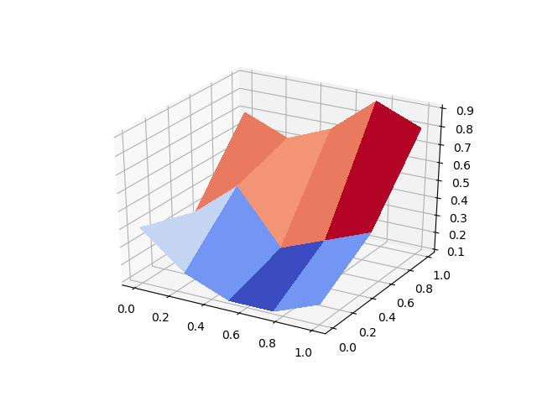

Surface and Wireframe Plots of the yield curve data should look somewhat like these, but with data for the year 2021 instead of for the year 2019. Short-term interest rates so far in 2021 are pinned at near 0 as a result of the Fed’s response to Covid-19. Long-term rates rose above 2% for a few months, but have recently fallen back below 2%.
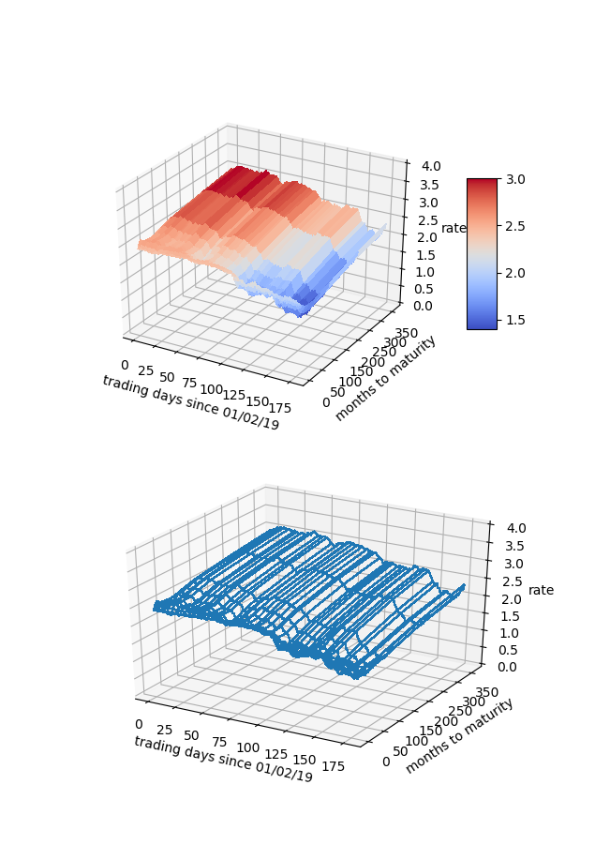

- Our interest rate table is a natural Pandas DataFrame, with trading dates as rows and bond maturities as columns. From the daily_yield_curves list of lists, create a DataFrame named yield_curve_df with the date strings as the row labels (‘01/02/2021’, …, ‘08/27/2021’, …), the bond maturities as the column labels
(‘1 mo’, …, ’30 yr’), and the corresponding interest rate values as the row/column item values. Use appropriate slices/loops/comprehensions involving daily_yield_curves to create yield_curve_df.

DataFrame has a plot() member function that uses matplotlib. You can use yield_curve_df.plot() to create a plot with rows on the horizontal axis, values on the vertical axis, and with each column represented as a different line. You will still need to use

plt.show()

to make the plot be drawn on your screen. Since the rows are trading days, this plot will be of the time series of interest rates for each maturity: 1 month, 2 months, 3 months, …, 30 years. You will see that during 2021, interest rates for all maturities have fallen. During March, short term rates fell dramatically when the Fed changed policy due to Covid-19.

Generally, it is considered more risky to lend for longer periods of time, so a “normal” yield curve slopes up: interest rates are lowest at 1 month, higher at 1 year, higher still at 10 years, and highest at 30 years. This is what we see for most days during 2021 so far.

If we transpose yield_curve_df, so that trading dates become the columns and maturities become the rows, then a plot() will show us the daily yield curve for every trading day so far this year. This will be an unreadable mess with over 100 lines.

From yield_curve_df create a DataFrame object named by_day_yield_curve_df, containing the transpose of yield_curve_df but only including a column for every 20th trading day, that is, day 0, day 20, day 40, …, day 160 (we are only a little over 2/3 of the way through 2020). The column labels should be ‘01/04/21’, ‘02/02/21’, ‘03/03/21’, … if you do this correctly. You will need to modify the row labels from ‘1 mo’, ‘2 mo’, and so forth, to the corresponding integer number of months—1, 2, …, 360—in order for the plot’s horizontal axis to make sense.

The by-maturity time series plot and the by-trading-day yield curve plots should look somewhat similar to the examples shown here, but for 2021 data rather than 2019 data:

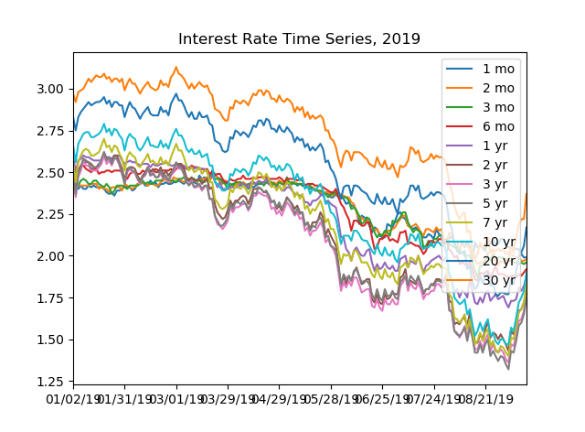

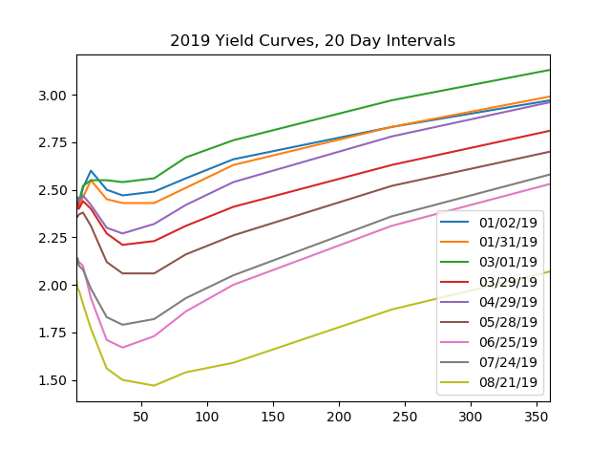

- European Options (20 points)

In this part of the homework, you will develop code for pricing “plain vanilla” European Call options. By “plain vanilla” we mean that the underlying asset pays no dividend, that the volatility of the underlying asset’s price movements is constant throughout time, that the payoff of the call/put is made at expiration time T and cannot be collected at any prior time, that the risk-free interest rate is constant, and the asset price evolution follows a geometric Brownian motion.

- In the Python development environment of your choice, open a copy of the OptionPrices.py file provided with this homework. OptionPrices.py contains the EuropeanCallOption class code that we saw in the Week 1 Part 3 Lecture, with the addition of a “pretty printing” function, binomialTreePretty, that lets you display small binomialTree objects in a clean way. Run the module. You will see that it displays the binomial tree at each step in the binomialPrice function’s algorithm. The backward induction code is yours to write—Your code here—so the reported option price at this point is $0.0000.

- Add the backward induction code, the formula for which is shown on slide 16 of the Week 1 Part 3 Lecture notes. Save and test. Here is the output that I get for a 5-step binomialPrice:

Binomial Tree Euro call price, 5 time intervals: $6.3598

- The call value computed with 5 time steps is pretty far off from the BSM price shown on slide 6 of the notes: $6.12. As you add time steps to the Binomial Tree (that is, as deltaT becomes smaller), the binomialPrice should converge to the BSM price. Uncomment the code for part 1.c that calls binomialPrice with time steps of 10, 20, 50, 100, 200, 500, and 1000. Save and test. Do the computed prices appear to converge?

- In the BSM and Binomial Tree models, given identical volatility, interest rate, and expiration time, the price of an option on a $5 stock with strike price $5 should be exactly 1/10 of the price of an option on a $50 stock with strike price $50. Likewise, the price of an option on a $500 stock with a strike price of $500 should be 10 times the price of $50 stock, $50 strike option. Uncomment the code for part 1.d that tests whether this is the case for the Binomial Tree pricing model. Save and test. What do you observe?

And Finally

Remember to put all team members’ names (Andrew IDs) in comments at the tops of your Jupyter notebooks and source code files.

Put your two Jupyter notebook files from part 1 and your expense_regex.py, b_soup_1.py, and OptionPrices.py files from parts 2 through 4 in a zip archive named Team_N_HW1.zip, where N is your team number. One team member should upload this zip archive to Canvas for grading before the due date/time.

